# INTRODUCTION

* 1. Overview

The project aim is to provide real-time knowledge for all the students to have basic knowledge of Salesforce and Looking for a real-time project. This project will also help to those professionals who are in cross-technology and wanted to switch to Salesforce with the help of this project they will gain knowledge and can include into their resume as well.

2.2 Purpose

This project helps in managing the ongoing and upcoming in an

Organization.

1. **Problem Definition & Design Thinking**
   1. Empathy Map

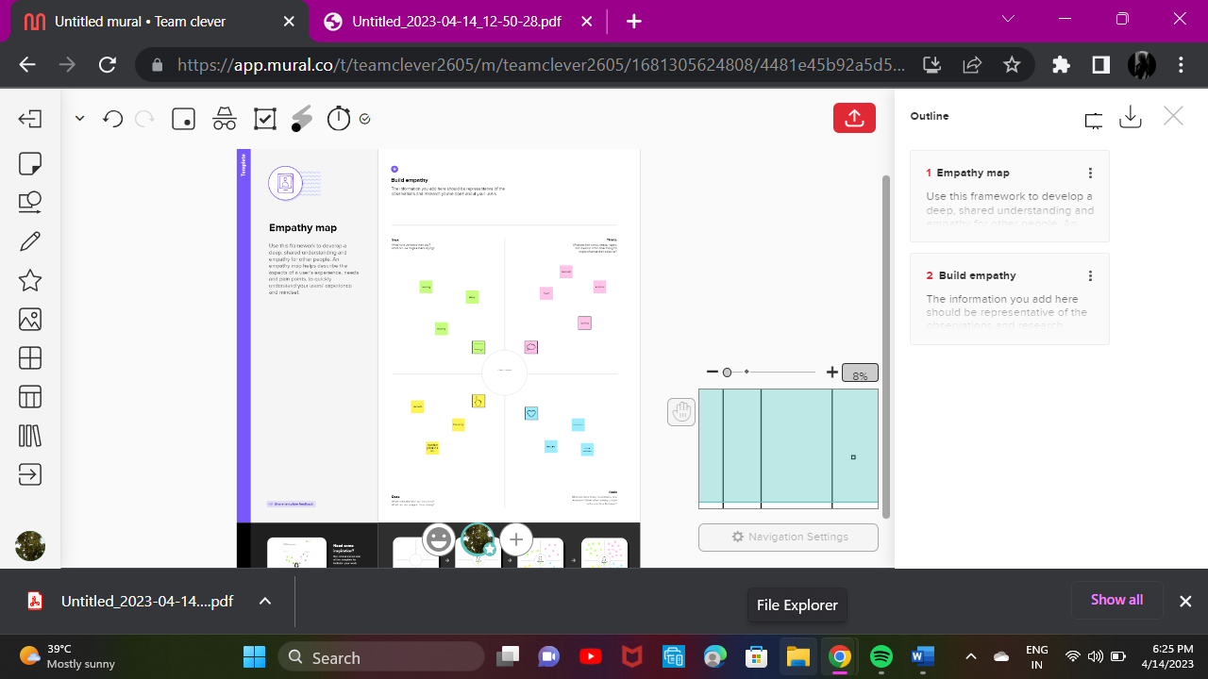

* 1. Ideation & Brainstorming Map

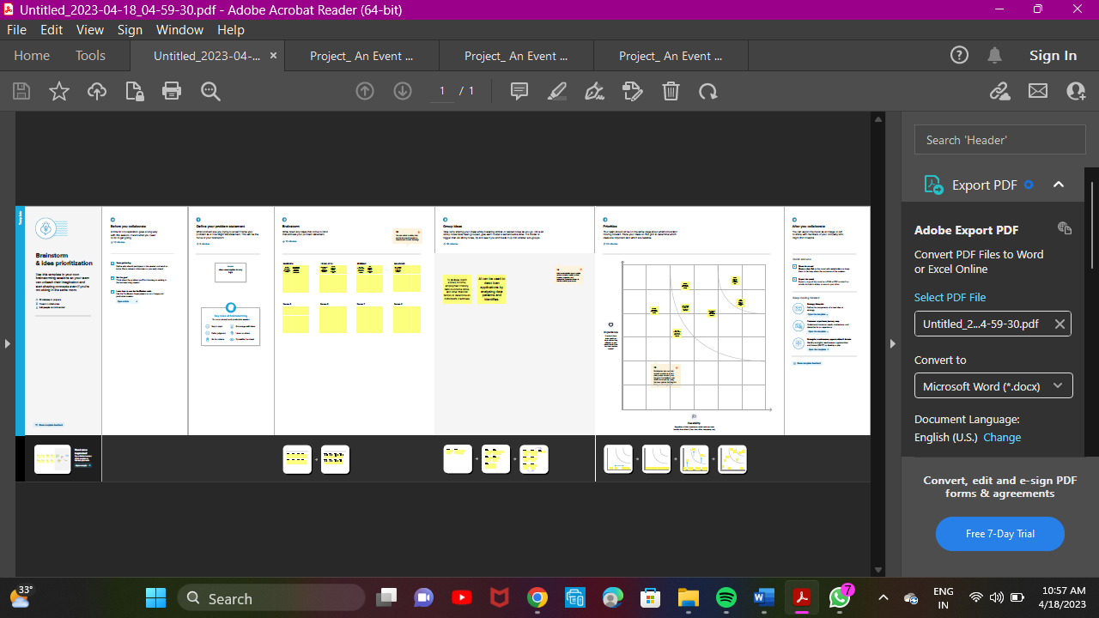

# RESULT

* 1. Data Model:

|  |  |
| --- | --- |
| **Object name** | **Fields in the Object** |
| Event | |  |  | | --- | --- | | Field label | Data type | | City | Text | | Phone Number | Phone | | Start Date | Date/time | |  |  | |
| Attendee | |  |  | | --- | --- | | Field label | Data type | | enter ID | Auto Number | | Phone | Phone | | Email | Email | |

# Activity & Screenshot

Attach the screenshots of your project activity along with the description.

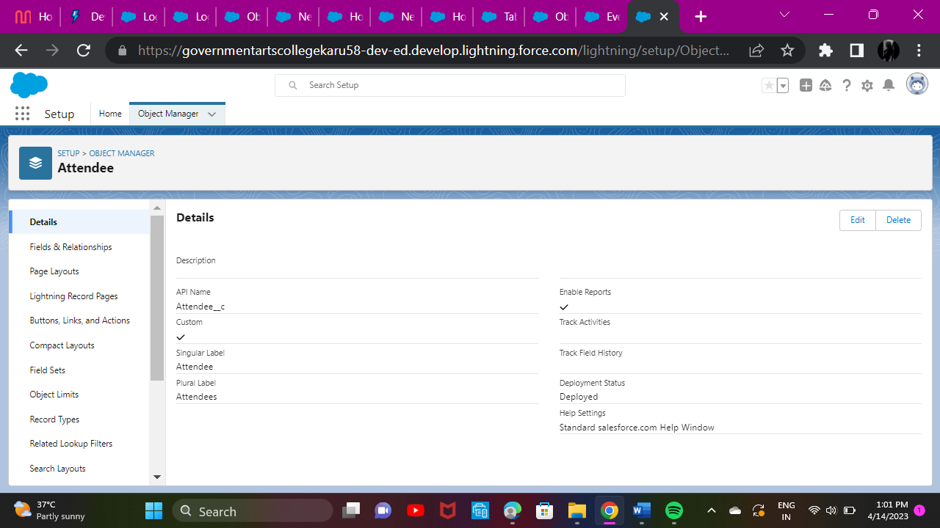

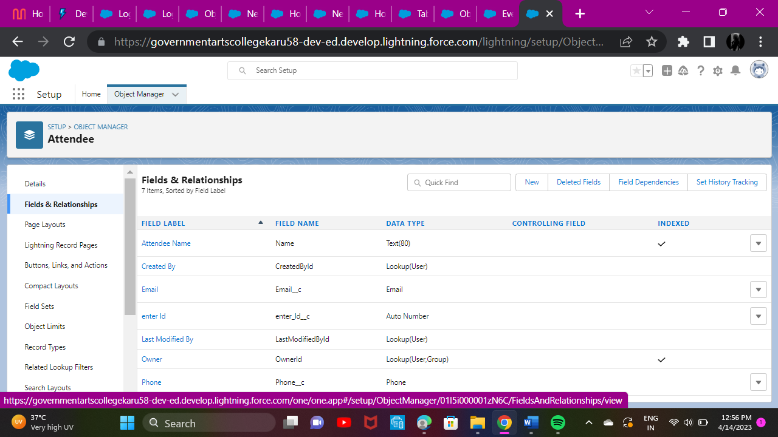

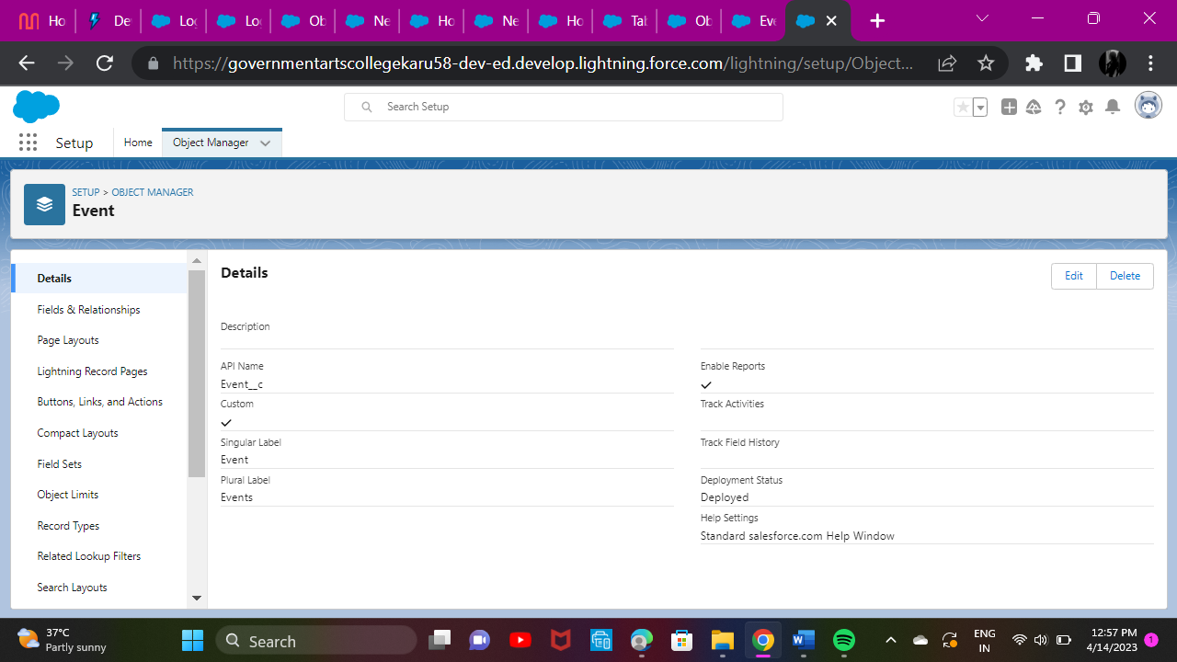

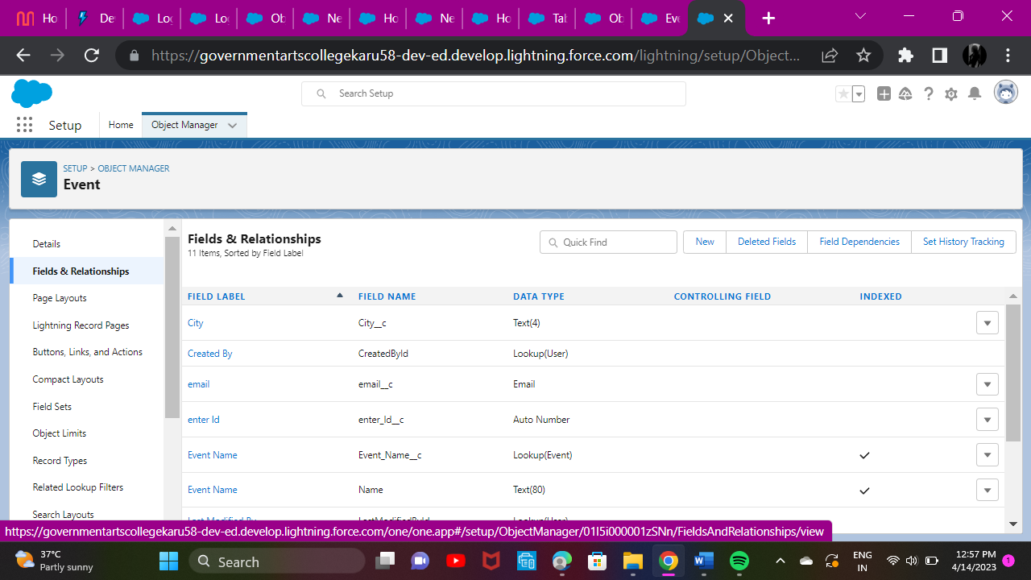

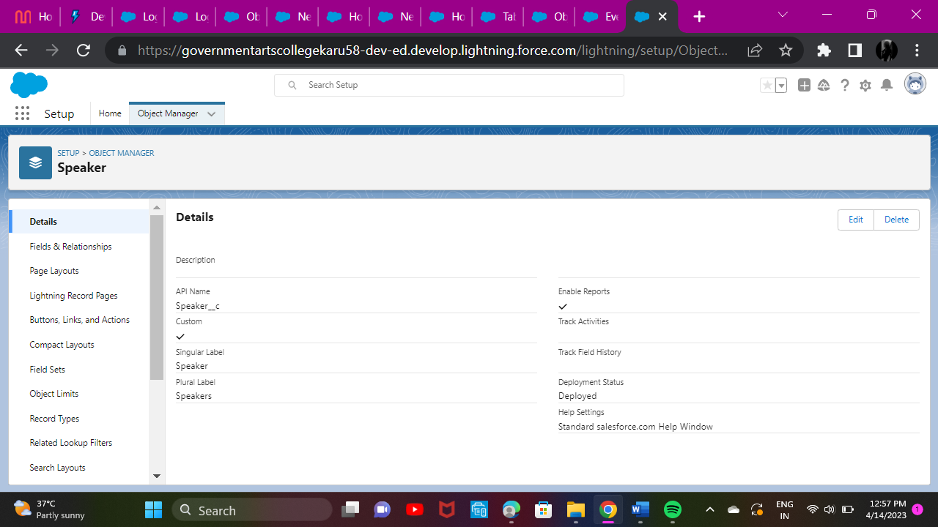

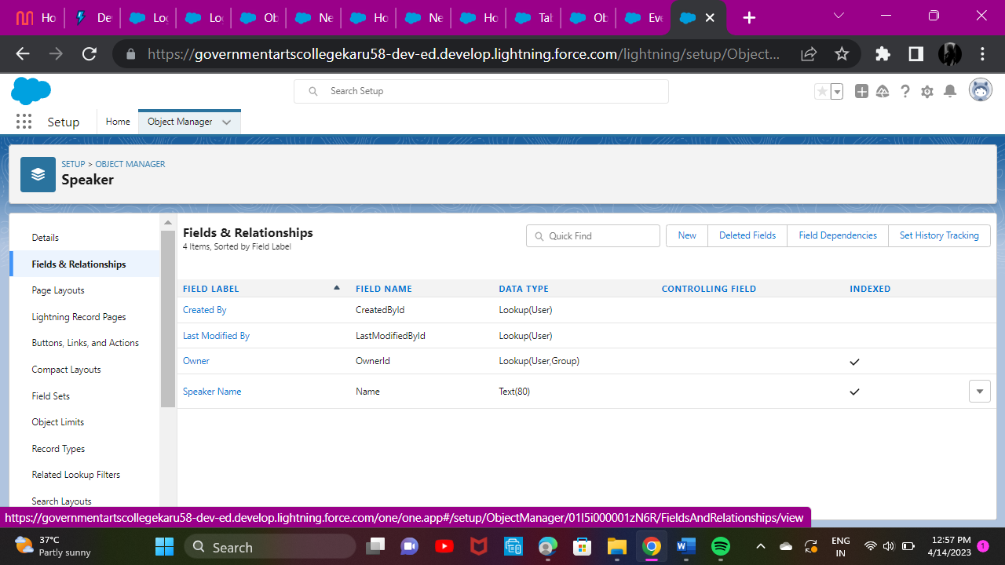

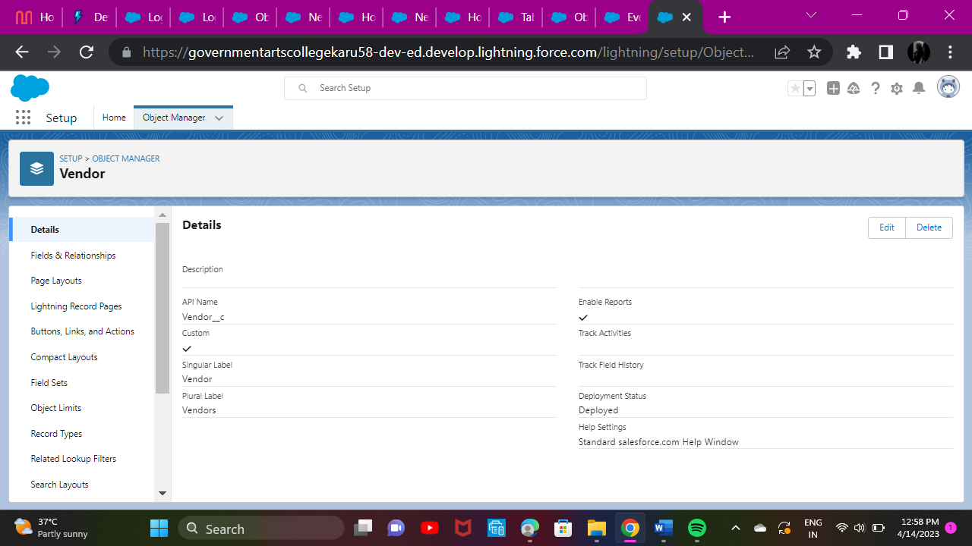

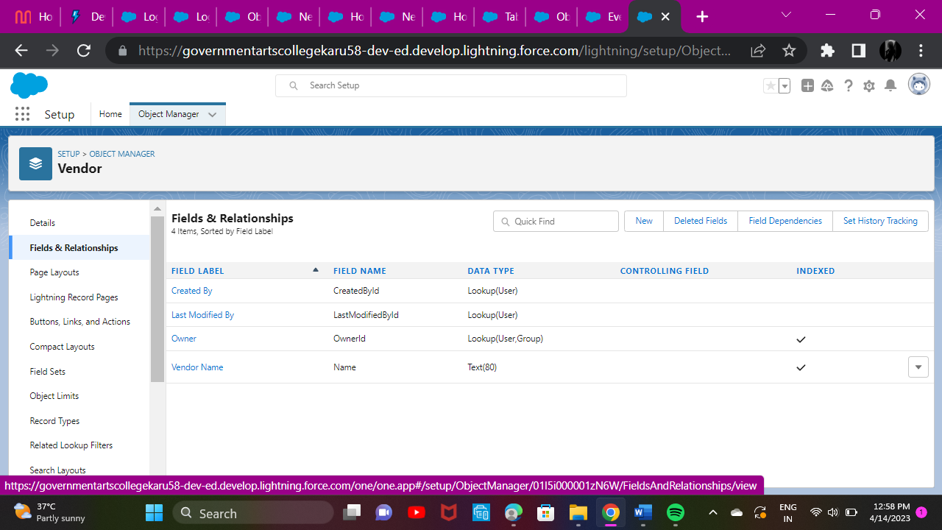

# Trailhead Profile Public URL

**Team Leader -** [**http://trailblazer.me/id/akanishca**](http://trailblazer.me/id/akanishca)

**Team Member 1 –**

[**https://trailblazer.me/id/hem10**](https://trailblazer.me/id/hem10)

# Team Member 2 –

# <https://trailblazer.me/id/jbaburaj11>

# `Team Member 3 –

<https://trailblazer.me/id/kvani52>

1. **ADVANTAGES & DISADVANTAGE**

ADVANTAGES:

* Provides a comprehensive start to finish event planning package for virtual and Live events.
* Helps to work a with a professional company with proper care of all the legalities.
* Makes less stressful and ensures runs smoothly.

DISADVANTAGES:

* Event Manager seek unpaid internships before advancing paid positions.
* Event Planners might travel often manage their tasks.
* Event Planners might spend an unlimited amount of time completing their responsibilities.

# APPLICATIONS

Event Project Manager works with clients to develop an overall budge as well as category specific budgets for certain elements of the event.

# CONCLUSION

* Event Management System is user friendly and cost effective system.
* It provides new edge to management industry.

# FUTURE SCOPE

* Event Management as a career us multifaceted activity.
* It involves management, creation and development of events.
* It involves a lot of research about the brand, target audience and the concept of the event before planning the actual events.